Christ Church Forest Hill
Rock Spring Parish
March 2022

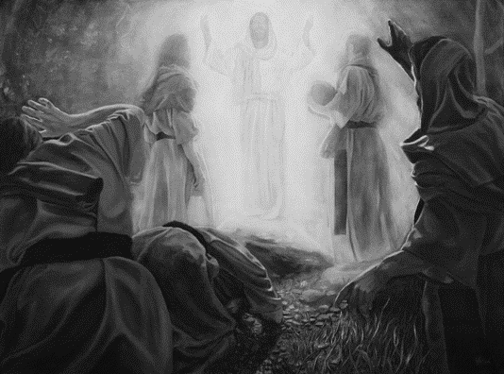

Christ Church Rock Spring Parish
2100 Rock Spring Road
P.O. Box 215
Forest Hill, MD 21050
Phone: 410-838-6606
Email: ChristChrsp@gmail.com
Website: www.ChristChurchForestHill.org

Office Hours: Tues & Thurs 10 – 2 (new hours) *
Please call prior to coming…Other hours by appointment.
Priest-In-Charge: Fr. Kirk Kubicek
Parish Administrator: Anna Risdorfer
Sexton: John Tipton
Vestry Officers: Molly Neal, Senior Warden
Jane O’Leary, Interim Treasurer
Tony Davis, Junior Warden
Kate Davis, Registrar
Music Team Leaders:
Marianne Kidd—Choir Director
Lyn Edmunds—Song Leader
Robert Hitz—Music Consultant

The Chimes

Dearly Beloved in Christ,

Wednesday, March 2, Ash Wednesday, marks the end of the Season of Epiphany and the beginning of Lent – so named because the hours of daylight are perceptibly lengthening day by day. February 27th, The Last Sunday after The Epiphany is the last chance to bring in last year’s Palms to be burned for the ashes of Ash Wednesday.
Once again, Christ Church will be offering Ashes-to-Go in the parking lot between the hours of Noon and 2:00 PM. You may ask for ashes to be marked upon your forehead or request a small baggie of Ashes to take home. I urge everyone to set aside some time at home to read through the Ash Wednesday Liturgy found on page 264 in the Book of Common Prayer (1979), paying particular attention to the Litany of Penitence which begins on page 267. Sunday, March 6 will be the First Sunday of Lent, which begins with musical preludes at 9:45, and Holy Eucharist beginning at 10:00am. You are welcome to attend in person (see the current mitigations in place on the next page), or watch the Live Stream on our Facebook Page or at christchurchforesthill.org, our parish website.
In other news, our Warm Hearts-Cool Worship campaign to pay of the cost of replacing the Chiller (which cools the church in the summer) has been paid-off by an Anonymous Donor! This is truly Good News and allows us to fully return the money we borrowed from the Cemetery Fund in full. Thank you to all who have been paying their pledges to pay off this major capital improvement in this campaign scheduled to conclude in June of 2022. Your faithfulness to the future of our church has made it possible to worship in cool comfort through the summer months.
In related news, our Annual Stewardship Campaign so far has 18 pledges for 2022 totaling approximately $56,000, just $10,000 short of the $66,000 necessary to balance the Proposed Budget for 2022 (which was. There is still time to make a pledge for 2022 to meet the current projected shortfall. Or, if you still have outstanding payments to make to the Warm Hearts-Cool Worship campaign, you may consider continuing to fulfill your pledge through June, as several of our Vestry have already pledged to do. All payments between now and the June conclusion of the campaign will be applied to the $10,000 projected shortfall in pledges and used for all of our projected 2022 expenses.
As Case Numbers and Hospitalizations due to Covid have continued to go down in Harford Country, our Vestry has scheduled our Annual Meeting for Sunday, March 20 in the Parish Hall after church, approximately 11:30am. Tables will be properly distanced, and we will be serving food and beverages that will be carry-out from a local vendor, not pot-luck. The principal business will be to recognize current Vestry and elect persons to fill vacancies that may remain; review the Proposed Budget 2022 and answer questions regarding parish finances; review possible updates to the Parish By-laws to reflect the current life of the parish. The By-laws were last updated in 2005. The main event, however, will be our first official Fellowship get together since the beginning of the Pandemic! We will be trying to call everyone to get an idea of our overall comfort to attend the Annual Meeting.
Finally, if you are looking for a Lenten Discipline this year, consider coming to Noonday Prayer on Facebook Live or christchurchforesthill.org, or view it later in the day. It includes Bible Study, Intercessory Prayer, and a short period of Contemplative Practice. It begins Live at 11:55 am Monday thru Friday. We are all invited to the observance of a Holy Lent!
Yours in Christ,
Fr. Kirk Kubicek, Priest in Charge

We are those people who Look Forward to a Return to In-Church Worship

Current statistics and projections for the next 60 days suggest, barring another variant of the coronavirus and accompanying surge of Cases, that by Holy Week and Easter 2022 we may be looking at some significant steps toward “normal” worship practices. This would include the possibility of being “mask-optional,” and returning to receiving the Blood of Christ from the Common Cup. Both of these steps, of course, are for those parishioners and visitors who feel comfortable with such changes. The Live Stream Worship option will always continue to be available.
Already we have returned to worship with the windows closed. By raising the temperature before 9:45am on Sundays, we will still keep the heat off during the service. Experience, however, has shown that keeping the service to approximately 45 minutes the temperature does not drop enough to make it uncomfortable in the church.
The service continues to be Holy Eucharist weeks 1, 2, 3 and 5 each month, with week 4 usually being Morning Prayer. Currently we only read a Psalm and The Gospel, and limited singing. We are singing the Sanctus and a Hymn at the end of the service, and in Lent we will begin singing the Trisagion, the Sanctus and a Hymn at the end. All worship and singing is currently with masks on.
The Reverend Scott Slater, who has been our Covid Mitigation officer throughout the Pandemic, has communicated an optimistic prediction that by Holy Week we may be able to move into Mask-Optional worship: those who are comfortable may worship without masks, while those who want to wear masks may of course continue to do so. Social Distancing will also become optional, but again, you may continue to sit wherever you feel most comfortable. Scott has also suggested that singing may soon become Mask-Optional as well.
A return to receiving the wine, the Blood of Christ, by the Common Cup will be a Diocesan-Wide decision made once Bishop Sutton returns from his sabbatical leave. What is known at this time is that in the Diocese of Maryland we will not return to Individual Intinction (the person receiving communion dipping the wafer in the cup). You may read in more detail what I wrote in the June-July Chimes which is still available at our website: christchurchforesthill.org. In summary, it has never been considered a healthy practice to have multiple hands dipping into the chalice and potentially touching the surface of the wine, thus causing possible contamination. As we know, disease is most often spread by hand-to-hand contact. It is also long been the practice of the Church universal that receiving only the Bread, the Body of Christ, is considered to be full-communion. When the wine is offered by the cup, the Chalicist first wipes the entire rim with the Purificator. It is always a personal decision whether or not to receive the wine. Once a decision has been made regarding a return to the Common Cup we can be assured there will be guidelines provided on how to do so. For now, we will be receiving the bread only.
As Holy Week and Easter come closer, there will be further updates regarding In-Church Worship. The safety of all involved is first and foremost what will be considered. Thank you for your patience and cooperation through these past two years of the Pandemic.

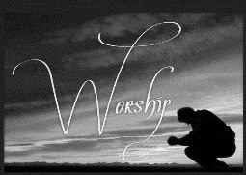
Stewardship Pledge Card
2022

In prayerful consideration of my/our stewardship of God’s resources, responsibility to Christ Church, and the desire to take the next step in my/our journey of faith, I/we pledge the following financial support to Christ Church for the 2022 church year:

Weekly $_______________

Quarterly $_______________

Monthly $_______________
For a total of $_______________ per year

Name: _________________________________________________________________
Address: ______________________________________________________________
_______________________________________________________________________
Phone #: _________________________ Email: _______________________________
- I would like to receive envelopes (circle one): YES NO
- Envelope #_______________

Signature: ________________________________________Date: ___________

Please return to Christ Church by mail.
Christ Church, Rock Spring Parish
P.O. Box 215

Forest Hill, MD 21050

Thank you and God Bless!


Christ Church
Altar Flower Dedications 2022

Please indicate whether you would like to pick up the flowers after the dedication date or leave for church use.

I would like to add the following dedications in 2022:

Date Preferred Sunday Dedication (as will appear in bulletin ex: In memory of, In honor of, In thanksgiving for) Pick Church
Up √ Use √

NAME: ____________________________________________ (PLEASE PRINT) Envelope #: ________________
Method of Payment ($25 contribution per Sunday)

Included______
Will send_____

Phone: ________________________

Please Send reminder one week before to: Email: ________________________________________________

Please mail this form to the office or place in the offertory plate.



Christ Church Vestry Minutes
January 19, 2022
[Virtual meeting via Zoom]

Attendance: Fr. Kirk, Lyn Edmunds, Molly Neal, Leslie Amtmann, Jane O’Leary and Kate Davis.

Meeting began at 7:05 PM with opening prayer.

The Vestry minutes from the last meeting were approved with one correction – under the Rector’s Report, the word “process” in the 3rd sentence should actually be “proceed.”

Treasurer's Report – Balance in our checking account is currently $17,168 of which $4,743 is reserved. Contributions were up a considerable amount, likely due to Christmas offerings. It appears to be a good idea to send out holiday collection envelopes in advance. Expenses were higher than normal, but not unusual for this time of year. The Warm Hearts Cool Worship campaign only has $1,957 to be paid off. Jane mentioned we’ve received 26 pledges for this year, so far. She also mentioned that we enrolled in Tech Soup to purchase technology/software for non-profits at discounted prices, so we now have QuickBooks Plus.

Leslie proposed the following actions, which were approved by the Vestry:
- We deposit the remaining amount of the gifts from the Necker and Rigdon families (totaling $7,945) into our T. Rowe Price investment account, so it can earn more interest. Both gifts were unrestricted.
- We transfer $2,000 from the main Harford Bank account into the Truist account (cemetery checking account), to prepare for upcoming expenses that will need to be paid.
Leslie sent us a copy of the 2022 budget for review. Our actual income in 2021 was about $102,000 and the estimated income for 2022 is about $96,000. We do not expect as many gifts/grants as we received in 2021, this year. The budget anticipates an estimate of $14,000 to be withdrawn from our investments (T. Rowe Price account) to cover expenses.

Cemetery Report – Leslie received two recent inquiries (from Arthur Chrise about his Aunt Rosalie Graham, and the family of Richard Webster about a marker in the Wilson family plot) which will require further investigation, as our cemetery records are sparse.

Rector’s Report – Fr. Kirk read a special message of appreciation for Leslie’s efforts as Treasurer over the past 5 years (it will also be posted in the upcoming Chimes newsletter).
In conjunction with the ongoing search for a new Bishop, there was a request from the Diocese for 5 pictures highlighting what makes our church special. Fr. Kirk will work on gathering these from our collection.
If COVID positivity rates decline enough by Shrove Tuesday (the day before Ash Wednesday), we may be able to have some type of celebration, even if it’s something to grab-n-go (e.g., cinnamon rolls to go) to maintain safe protocols.
The Sunday services have been trimmed back to about 45 minutes in length, in keeping with the latest safety recommendations from the Diocese. In-person attendance has been about 8-10 people lately. It’s important to get the word out that cloth masks are not as effective as KN95 masks or surgical masks.

Sr. Warden’s Report – Molly pointed out that the check signers for all active checking accounts need to be revisited and updated, as needed. A motion was made to update the check signers for the first three bank accounts listed below (Truist, Edward Jones and T. Rowe Price) as follows:

 | Bank | Account ending in | Check Signers (eff. 2022)
1 | Truist (formerly BB&T) - Cemetery Checking | xxxxxxx7928 | Maureen (Molly) Neal - Sr. Warden  George A. (Tony) Davis - Jr. Warden  Leslie Amtmann - Member & Former Treasurer
2 | Edward Jones - Cemetery Investments | xxxxxx05-1-0 | Maureen (Molly) Neal - Sr. Warden  George A. (Tony) Davis - Jr. Warden  Leslie Amtmann - Member & Former Treasurer
3 | T. Rowe Price - Parish Investments | xxxxxx2827 | Maureen (Molly) Neal - Sr. Warden  Leslie Amtmann - Member & Former Treasurer  Jane O’Leary - Acting Treasurer
4 | Harford Bank - Parish Checking | xxxxxx5676 | Fr Kirk Kubicek - Priest-in-Charge  Maureen (Molly) Neal - Sr. Warden  Leslie Amtmann - Member & Former Treasurer  Jane O’Leary - Acting Treasurer  2 signatures required over $3k
5 | Harford Bank - Clergy Discretionary Fund | xxxxxx8730 | Fr Kirk Kubicek - Priest-in-Charge)  Maureen (Molly) Neal - Sr. Warden
6 | Jarrettsville Federal - ECW | xxxxxx7112 | Melinda Chase - ECW Treasurer  Leslie Amtmann - Former ECW President
7 | PNC - ECW | xxxxxx1929 | Melinda Chase - ECW Treasurer  Leslie Amtmann - Former ECW President

The Vestry voted to approve the above list of check signers for the first three bank accounts (Truist, Edward Jones and T. Rowe Price). Note, the Vestry approved the check signers for the two Harford Bank accounts previously via email (dated January 7, 2022, from Molly Neal to Vestry members). The two ECW accounts did not need any changes, at this time.

The main Harford Bank account automatically sends an email notification to the church’s email address whenever $2,500 is withdrawn, as a security measure. The Vestry approved to maintain the threshold at which 2 signatures would be required on checks at $3,000.

An updated contact listing for the new Vestry members was sent to us by Anna.

Jr. Warden’s Report – both Molly and Dave have met with Tony to review items related to the Jr. Warden role. Currently, there has been an issue with the fire alarm system in the Annex setting off false alarms. Molly and Tony will work with Town Security to further investigate to resolve the issue. Also, Tony cleaned out the drains in both the women’s and men’s bathrooms in the Parish Hall, as they were draining slowly.

Green Team update – the team has started to organize/plan for the new year. It was recently found out from Mark Gatza that the foot stones were removed from the cemetery and moved to the gully in the woods (where Rock Spring is) circa 1992, in order to reduce the costs/complications related to the lawn mowing service. Families had been given the opportunity to pick up their foot stones.

We will collect old palms again in February, so they can be burned into ashes before Ash Wednesday.


The next meeting will be on 2/16 at 7:00pm.
At 8:48 pm, the meeting ended with a closing prayer.

Blessings,
Kate Davis

***********************************************************************************************
A BIG THANK YOU

Special thanks to Len and Mary Jane Parrish
for their generous donation of a new paint job in the sacristy. It really needed it.



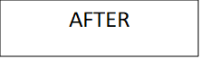
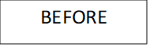
BEFORE
AFTER



Don’t forget …Set your clocks
forward one hour
Sunday, March 13^{th,} 2:00 a.m.



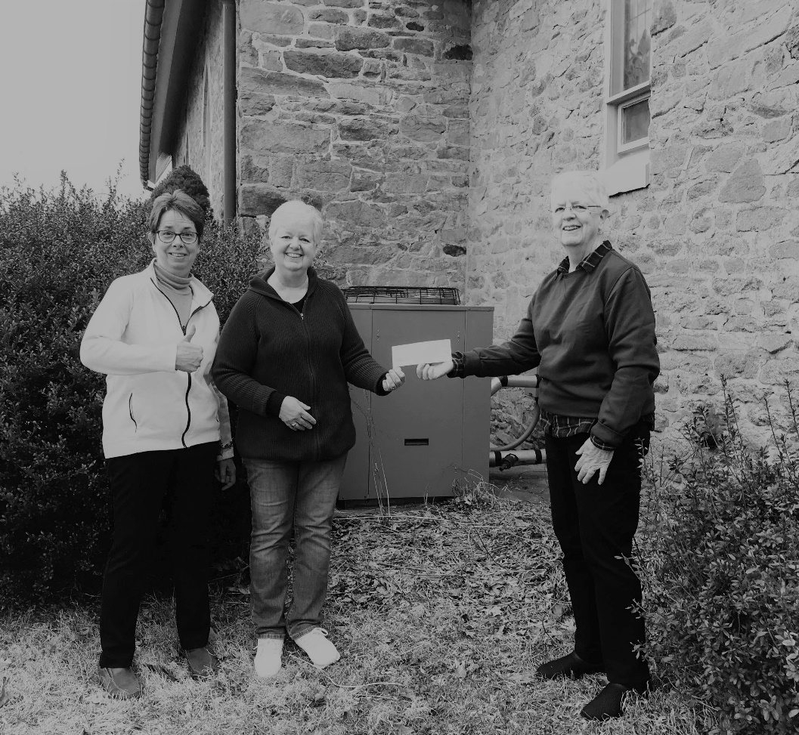
A
WE DID IT
reason
to celebrate

The church chiller has been paid off

Thanks to all the Friends and Family of Christ Church for your steadfast financial support toward the Warm Hearts-Cool Worship Campaign.

What an awesome Small but Mighty group we are! God is Good! Photo 2.22.22
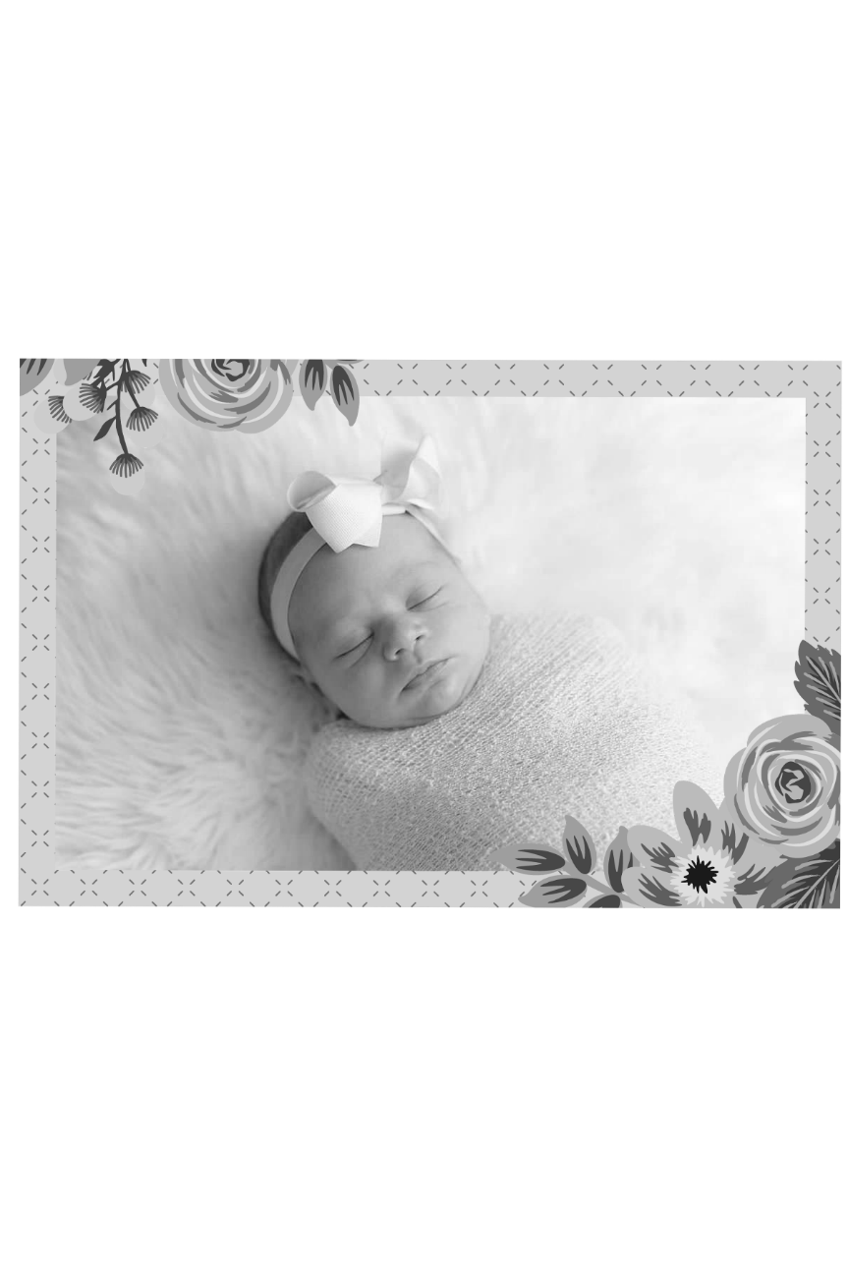

Proud parents Adam and Brooke with big sister Hollis welcomed ….

Isabelle Susan Eaton
January 30, 2022
7:01 pm
7 pounds
19 1/4 inches long



Weekly EnvelopeS
“A man’s true wealth is the GOOD HE does in this world.”
Muhammad (570-632 CE)

Blessings report

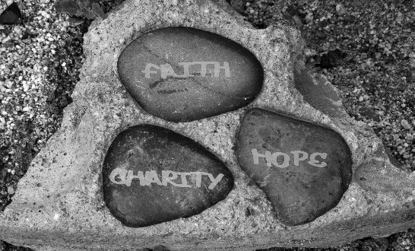
February total is $4,480.

We need $2,000 each week
to meet our expenses.

Marianne Kidd 410-937-0865
HMDHub@gmail.com
www.Facebook.com/HMDHub
Hand Me Down Hub
Please remember to
mail your offering to:

Christ Church
P.O. Box 215
Forest Hill, MD 21050
(Do not include the street address)
Remember to …..
include your parishioner number on the envelope. It helps ensure accuracy of our records.

Infant to Teen sizes available.
Send a request for yourself
or another.

Many thanks for your generosity.


If you need envelopes or have questions regarding your giving statement, please contact Jane O’Leary

HAPPY BIRTHDAY

March
1 – Mallory Kubicek
4 – Clay Lejeune
9 – Richard Tidey
14 – Sharon Selke
23 – Ezra Kidd
25 – Patrick Chase
26 – Becky Borkowski-Johnson
27 – Zachary Clayton
30 – Laurie Morris
19 – St. Joseph
Psalm: Psalm 89
1st Lesson: 2 Samuel 7:4,8-16
2nd Lesson: Romans 4:13-18
Gospel: Luke 2:41-52

25 - Annunciation of our Lord Jesus Christ to the
Blessed Virgin Mary
Psalm: Psalm 45
1st Lesson: Isaiah 7:10-14
2nd Lesson: Hebrews 10:4-10
Gospel: Luke:1:26-38

Please PRAY for those who are sick, in any kind of need or difficulty, especially:
For the residents of Harford Family House; For peace and understanding in Baltimore; For all the victims of recent terror attacks throughout the world; For the refugees leaving Syria and Central America in desperation; For those who suffer because of the extreme humanitarian crises; For all the people in the Middle East, that they can experience peace and stability in their lands; For the victims of natural disasters; For the communities that have experienced Mass Shootings & Riots.

For those on our prayer list: For Sue Tressler, Lynn Klein, Kevin & Linda, Anna Humphreys, Phil Klein, Betty Parker, Beverly Gomez, Tara Schatzel, Dan Moss, Ken Edmunds Jr, Robin, Keith Hamilton, Sharon Selke, Sharon Slaugenhoup, Warren Flatt, Caroline, Donald Heddy, Karen Fulcomer, Art Smith, Eliot, Rebecca, Louise, Carole, Becky, Don, Peter, Lael, Jacqueline, Hollis, Mike Yates, Sue Sampson, Lois & Richard Tidey, Catherine Horchner, Ken, Libby Ohl, Judith Herseth, Mary Tucci, Sherry Cole, Silvia Meranski, Sam Robertello, Eileen Shaver, Nancy Capricciuolo, Blake Gude

For our Missionary: Jean M. Baumbach

For these parishioners who are unable to be with us every Sunday:
Glassell & Betty Parker; Anna Humphreys; Beth Hauser; Lyndon


HAPPY ANNIVERSARY

March
4 – Scott & Marianne Kidd
13 – Celebration of Adoption Day for
Nadia & Slava Morris

This Photo by Unknown Author is licensed under CC BY-NC

The LORD has done great things for US, and we are filled with joy.
Psalm 126:3
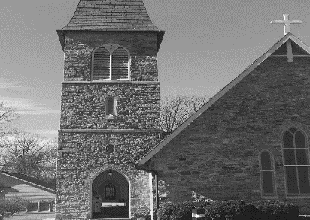
Christ Church Rock Spring Parish
March 2022
In the Episcopal Diocese of Maryland
2100 Rock Spring Road
P.O. Box 215
Forest Hill, MD 21050
Sunday  9:45 am Live/In Person  Morning Prayer  (4th Sunday)  Comm Service  (1st, 2nd, 3rd, 5^{rh}  Sundays) | Monday  9:00-11:00a  Jazzercise  5:30-6:45p  Jazzercise  7:00-9:00p  AA—Mon Night Raw | Tuesday  9:00-11:00a  Jazzercise  10 am Quilters  6:50-7:50p  Aerobics  8:30-9:30p  AA—Primary Purpose | Wednesday  9:00-11:00a  Jazzercise  5:45-7:45p  Jazzercise | Thursday  9:00-11:00a  Jazzercise  6:50-7:50p  Aerobics  8:30-9:30p  AA—Primary Purpose | Friday  9:00-11:00a  Jazzercise  7:00-8:00p  AA—Fri Night Group | Saturday  8:30-10:30 a  AA—New Beginnings
 |  | 1  Live Stream  11:55 noon prayer | 2 Ash Wednesday    Live Stream  11:55 noon prayer | 3  Live Stream  11:55 noon prayer | 4  Live Stream  11:55 noon prayer | 5
6  The 1st Sunday in Lent  9:45 am  Communion Service  AG– Melinda | 7  Live Stream  11:55 noon prayer | 8  Live Stream  11:55 noon prayer | 9  Vestry Meeting  Live Stream  11:55 noon prayer | 10  Live Stream  11:55 noon prayer | 11  Live Stream  11:55 noon prayer | 12
13  The 2nd Sunday in  Lent  9:45 am  Communion Service  AG—Kate | Live Stream  11:55 noon prayer | 15  Live Stream  11:55 noon prayer | 16  Live Stream  11:55 noon prayer | 17  Live Stream  11:55 noon prayer | 18  Live Stream  11:55 noon prayer | 19 St. Joseph  
20  The 3rd Sunday in Lent  9:45 am  Communion Service  AG– Debbie | 21  Live Stream  11:55 noon prayer | 22  Live Stream  11:55 noon prayer | 23  Live Stream  11:55 noon prayer | 24  Live Stream  11:55 noon prayer | 25  Annunciation of our Lord Jesus Christ to the  Blessed  Virgin Mary  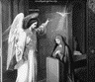  Live Stream  11:55 noon prayer | 26
27  The 4th Sunday in Lent  9:45 am  Morning Prayer  AG–MJ | 28  Live Stream  11:55 noon prayer | 29 | 30 | 31
Office Phone: 410-838-6606 Email: christchrsp@gmail.com Office Hours: By appointment only

